Steps to create a trigger:-

1. Click on the 4 dotted lines below to visit resources list:-

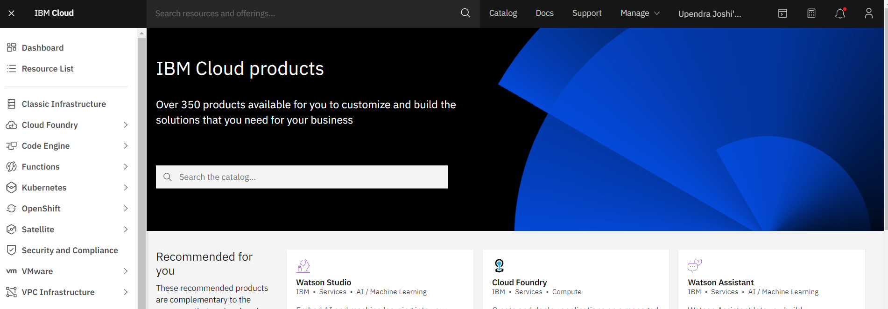

1. Click on side menu names Functions -> Actions

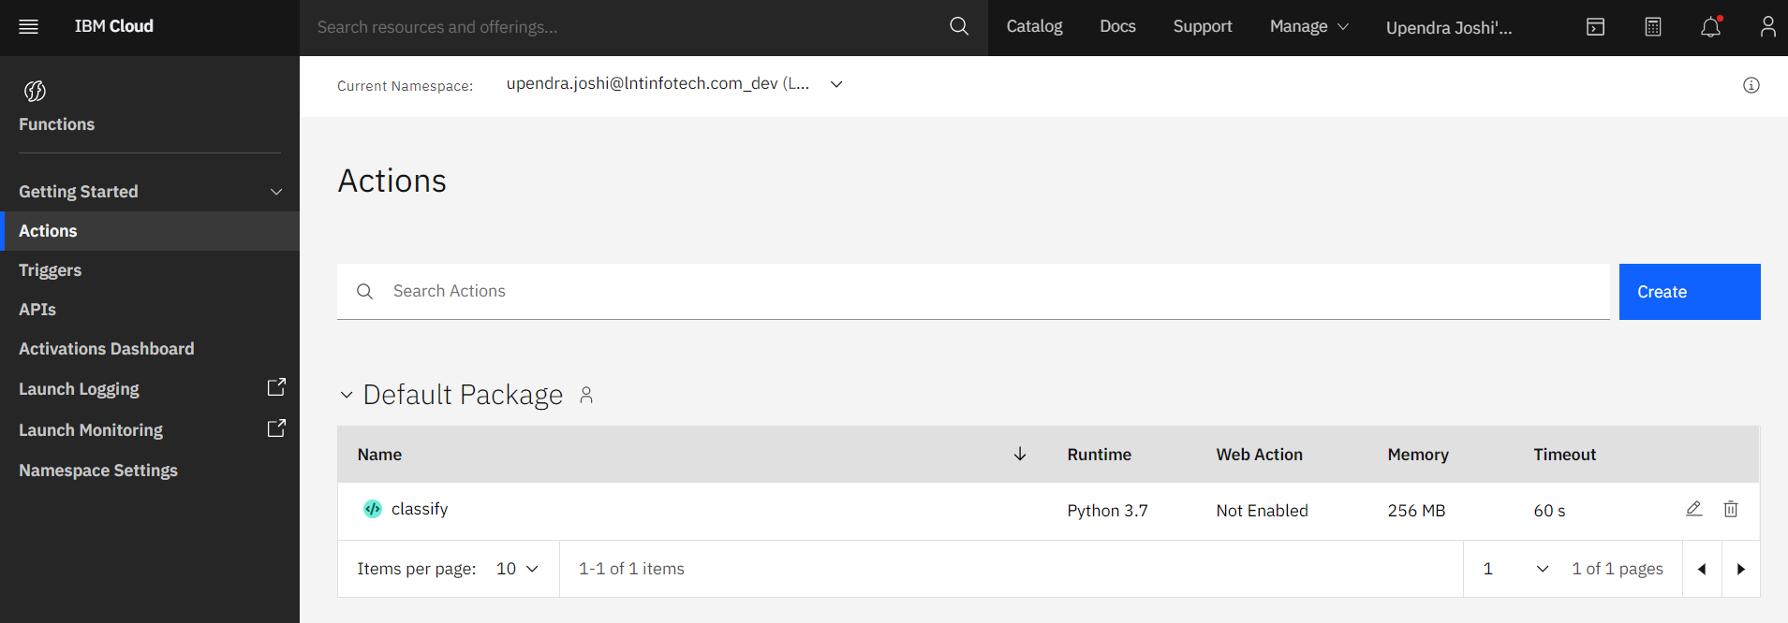

1. You can see I already have one action created for my api named classify same way you can created clicking on create button.

And you will land to below page next click on Action.

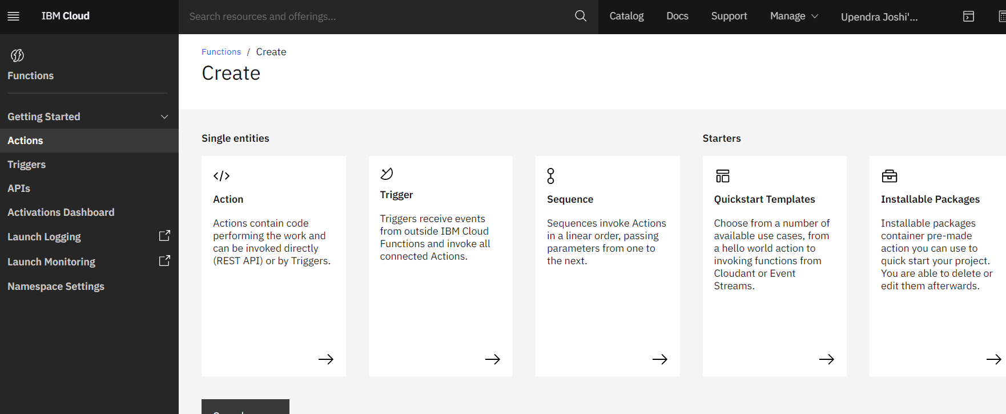

1. Provide the action name ,let package remain default and change runtime to python 3.7 and click on create.

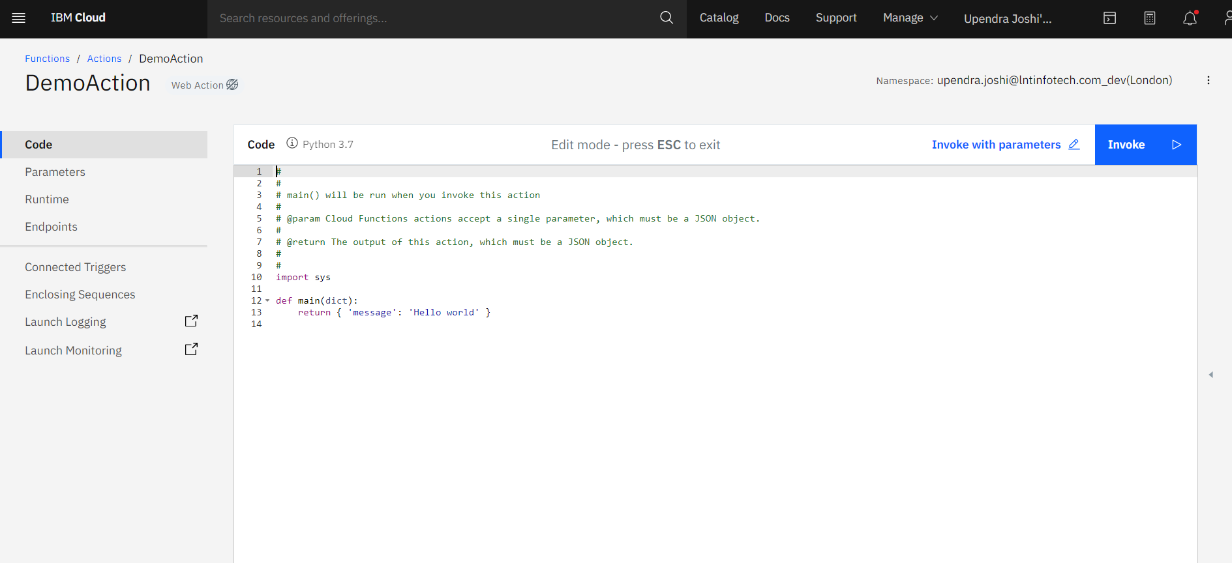

1. You can paste in the code provided in the README file.
2. Rest all steps would be same as given in README file.